NEW THYREOPHORAN REMAINS WITH STEGOSAURIAN AFFINITIES FROM THE LOWER CRETACEOUS OF ARGENTINA

FACUNDO JAVIER RIGUETTI, SEBASTIÁN APESTEGUÍA, JUAN IGNACIO CANALE, and PABLO ARIEL GALLINA

APPENDIX S1
PCA methodology
With the aim of making an accurate identification through shape analysis we performed a Principal Component Analysis (PCA) of the sacral fragments MMCh-PV 293 and 294, following the methods proposed by Klingenberg (2011; see also Villalobos Leiva and Benítez, 2020). Although the digitized material of sacral elements in ventral view is scarce, we proceeded with an exhaustive bibliographic sampling of sacra of worldwide vertebrate clades compatible in size and age with the sacral elements from Bajada Colorada. Since no obvious contact is conserved between both fragments, one PCA was carried for each one complemented with a Canonical Variate Analysis (CVA). We considered a priori taxonomic groupings of variable hierarchy in order to test shape homogeneity within each group and the similarities of the Bajada Colorada remains to those groups. For the analysis with MMCh-PV 293, the group Sauropoda was subdivided into Diplodocoidea and Macronaria after preliminary testing analyses, due to the extensive morphospace occupation of the former. For the analysis with MMCh-PV 294, we conserve the group Sauropoda because this element is recovered outside the confidence ellipse and then a subdivision doesn’t contribute relevant information. Thus, the groups are listed by letters as: B= basal Thyreophora, D= Diplodocoidea, M= Marginocephalia, O= Ornithopoda, P= “Polacanthinae”, S= Stegosauria, T= Theropoda, X= MMCh-PV 293/294 and Z= Sauropoda (Analysis 1) or Macronaria (Analysis 2). The ornithopod Macrogryphosaurus was first hand sampled. Using the software TpsDig, we placed 13 and 10 landmarks for MMCh-PV 294 and MMCh-PV 293, respectively (Suppl. Fig. 1). The landmarks were placed in order to study the shape of the sacral fenestrae, the relative width of the vertebral centra, and both the lateral extension and sturdiness of the sacral ribs. No landmarks were placed on the lateral surface of sacral ribs (“iliosacral yoke”) because these are poorly conserved. All analyses were carried out with the software MorphoJ following Klingenberg (2011).
PCAs results: general comments
The first analysis yielded 22 principal components (PCs), of which the first 6 accumulate 90.0% of the total variability, while the second analysis recovers 16 PCs, with 92.4% of the total variability within the first 7 PCs. In the analysis of the anterior portion of the sacrum (Suppl. Fig. 2), the PC1 explains 54.6% of the total variation, the PC2 14.1%, and 95% of the total variation is reached with the accumulation of the first 9 components. In the second analysis (posterior part of the sacrum; Suppl. Fig. 3), the contribution of each component is quite similar to those in the first analysis: the PC1 explains 48.2% of the total variation, the PC2 14.6%. %, and 95% of the total variation is achieved with the first 9 components. Therefore, although the contribution of the PC1 is the majority in both analyses, these are not sufficient to explain the observed variability on their own.
The PC1 of both analyses are mainly associated with a lateral expansion of the sacral elements (see deformation schemes; Suppl. Figs. 2 and 3). Along this component, there is an elongation of the sacral ribs and the associated fenestrae, the latter changing the main axis from anteroposterior in negative values of CP1 to lateromedial in positive values. In the morphospaces, narrow sacra are mainly represented by theropods and ornithopods towards the left (negative values of CP1), while wider sacra are represented by thyreophorans towards the right (positive values of CP1). Sauropods represent a wide spectrum of shapes, although most are located towards higher values of CP1 in both morphospaces. This variation is probably associated with locomotor differences (bipedalism vs quadrupedalism). In fact, this variation is also observed within Thyreophora, where facultative bipedal taxa such as Scelidosaurus (also related to bipedal taxa like Scutellosaurus or Jakapil), are further to the left than the rest of the thyreophorans. In the second analysis, the greater overlapping towards higher values of the PC1 shows a more conservative shape of the posterior region of the sacrum, especially in quadruped clades. Similar shape variation was observed by Maidment and Barrett (2014) in the width of the ilium of ornithischian dinosaurs. They found that wider ilia are well correlated with quadruped forms. MMCh-PV 294 (the anterior portion of the sacrum of Bajada Colorada = Bajada_N_X in Suppl. Fig. 2) is recovered outside the confidence ellipses of all the sampled groups, with lower distance values for the mean of Ornithopoda, Sauropoda and Stegosauria (see appendix). However, the closest individual in the morphospace is Huayangosaurus (Huaya1_I_S), which is also located just outside the confidence ellipse of Stegosauria. MMCh-PV 294 is placed at around -0.05 in CP1 and 0.1 in CP2, so its shape presents an average lateral extension (width) of its elements, and large size of the intercostal fenestrae relative to the width of the vertebral centra (anatomical characteristic that separates it from sauropods).
In both graphs, the PC2 represents the variations associated with the size and position of the intercostal fenestrae relative to the sagittal plane (associated with the width of the vertebral centra). Along the PC2, the fenestrae increase both their size (more noticeable in the second analysis) and their proximity to the sagittal plane, associated with a decrease in the width of the vertebral centra (Suppl. Figs. 2 and 3). The groups show a more extensive distribution in the morphospace, with a marked tendency to bear large fenestrae in ankylosaurs and basal thyreophorans in both analyzes (shared with ornithopods in the analysis of the posterior portion of the sacrum). The first analysis also shows a slight tendency in having larger fenestrae and smaller width of the vertebral bodies in the anterior portion of the sacrum in most groups except sauropods, where the majority are located in negative values of the component (small fenestrae and wide vertebral centra; Suppl. Fig. 2). MMCh-PV 293 (posterior portion of the sacrum of Bajada Colorada = Bajada_N_X in Suppl. Fig. 3) is recovered within the confidence ellipses of both sauropod groups (diplodocoids and macronaria) and close to the ellipses of thyreophorans. In fact, the closest individual to MMCh-PV 293 in the morphospace is Stegosaurus stenops (StegS3_I_S), which is located at the external limit of the confidence ellipse of Stegosauria. MMCh-PV 293 is located around the 0.0 in both components, therefore bearing an average lateral extension of its elements and an average size of the intercostal fenestra relative to the other groups.
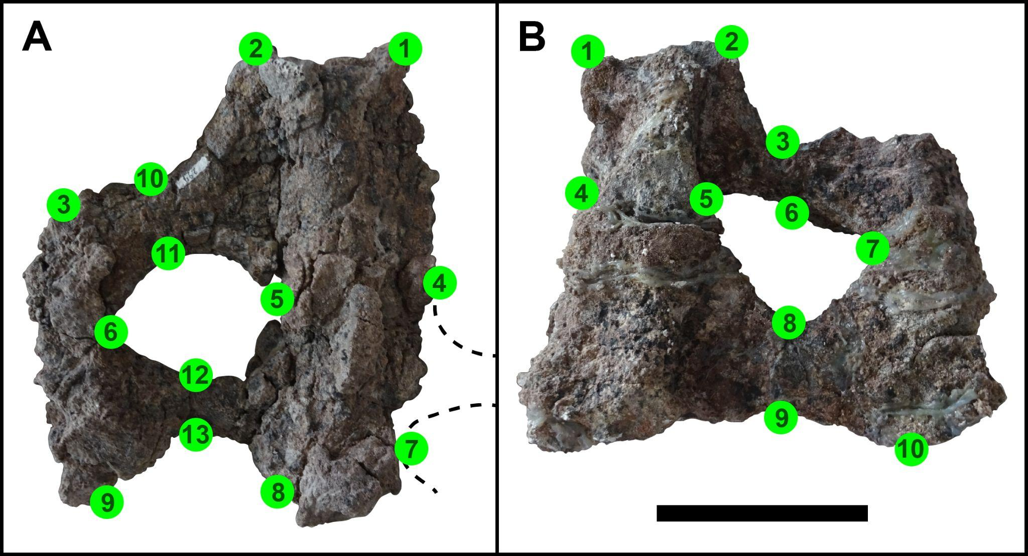
Suppl. Fig. 1. Landmarks placement in MMCh-PV 293 (A) y 294 (B) (ventral views). Landmarks are placed in: anterior end of the sacral rib (landmarks 1 and 2 in A and B), medial end of the intercostal fenestrae (5,4,7 and 8 in A; 4 and 5 in B), lateral limit of the intercostal fenestrae (6 and 9 in A; 7 in B), anterior and posterior limits of the thinner point of the sacral ribs (10, 11, 12 and 13 in A; 3, 6, 8 and 9 in B) and the anterior (3 in A) and posterior (10 in B) ends of the distal rib fusion. Scale= 10 cm for both A and B.
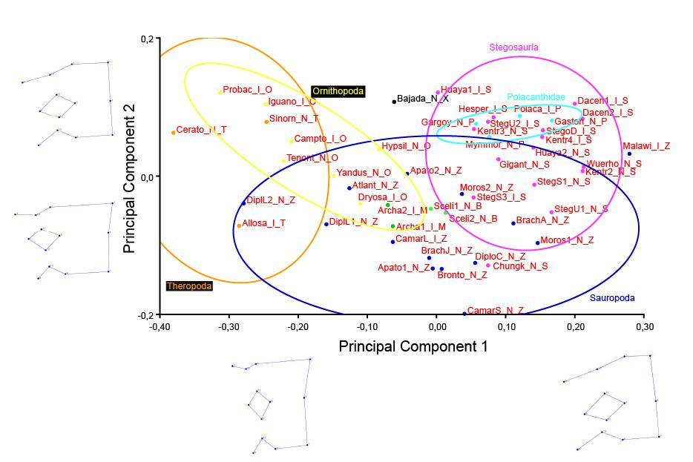
Suppl. Fig. 2. PCA of MMCh-PV 294, the anterior sacral fragment. The acronym of MMCh-PV 294 (Bajada_N_X) is in black. Deformation grids of extreme values are placed on each principal component (-0,25 and 0,25 in the PC1; -0,1 and 0,1 in the PC2). Confidence ellipses of Ornithopoda (yellow), “Polacanthinae” (light blue), Stegosauria (pink), other ornithischians (green), Sauropoda (blue) and Theropoda (orange) are shown.
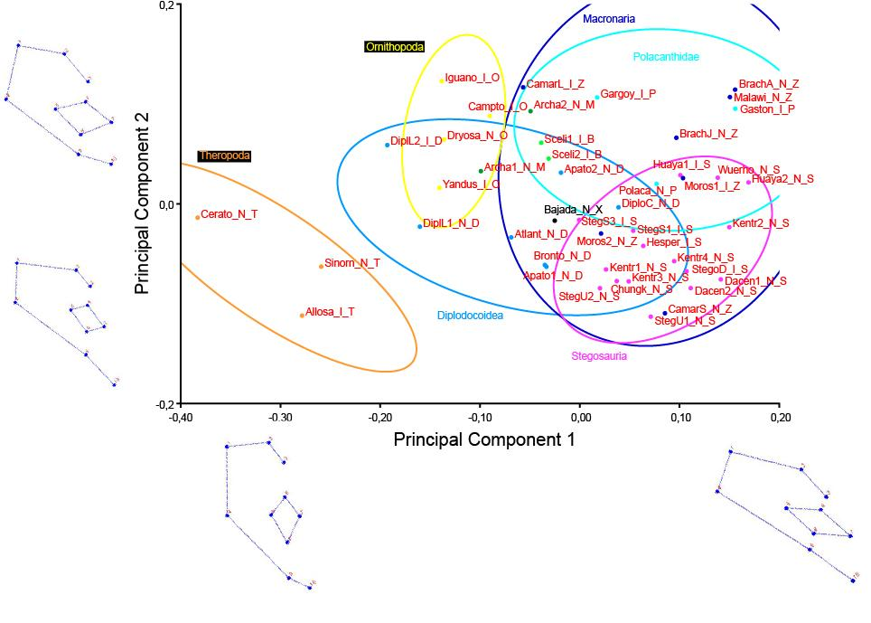
Suppl. Fig. 3. PCA of MMCh-PV 293, the posterior sacral fragment. The acronym of MMCh-PV 293 (Bajada_N_X) is in black. Deformation grids of extreme values are placed on each principal component (-0,3 and 0,2 in the PC1; -0,1 and 0,1 in the PC2). Confidence ellipses of Diplododoidea (turquoise), Macronaria (blue), Ornithopoda (yellow), Polacanthidae (light blue), Stegosauria (pink), other ornithischians (green) and Theropoda (orange) are shown.

Quantitative results of the PCA for MMCh-PV 294
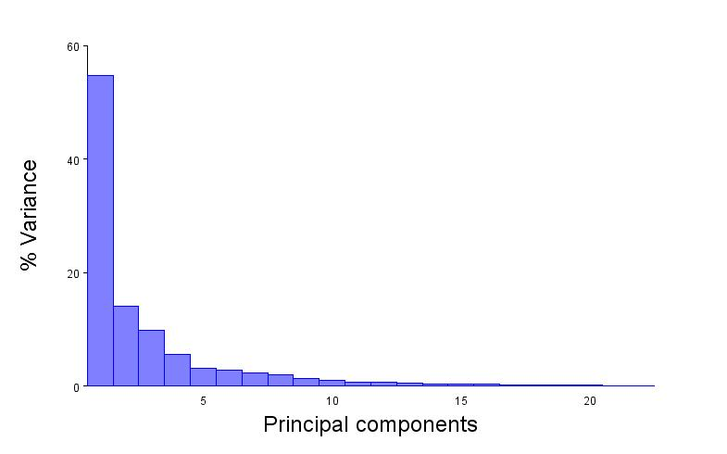
Suppl. Fig. 4. Proportion of the total variation explained by each principal component in the first analysis (MMCh-PV 294)

Principal Component Analysis: PCA: CovMatrix, newDataset, Procrustes coordinates
Eigenvalues % Variance Cumulative %
1. 0,02516683 54,627 54,627
2. 0,00649363 14,095 68,721
3. 0,00450974 9,789 78,510
4. 0,00258232 5,605 84,115
5. 0,00145908 3,167 87,282
6. 0,00126000 2,735 90,017
7. 0,00106950 2,321 92,339
8. 0,00086606 1,880 94,219
9. 0,00058410 1,268 95,486
10. 0,00044140 0,958 96,444
11. 0,00032593 0,707 97,152
12. 0,00031450 0,683 97,835
13. 0,00021351 0,463 98,298
14. 0,00017712 0,384 98,682
15. 0,00016067 0,349 99,031
16. 0,00013407 0,291 99,322
17. 0,00009675 0,210 99,532
18. 0,00006989 0,152 99,684
19. 0,00005043 0,109 99,793
20. 0,00004336 0,094 99,888
21. 0,00002708 0,059 99,946
22. 0,00002475 0,054 100,000
Total variance: 0,04607071

Variance of the eigenvalues: 0,0000278435026
Eigenvalue variance scaled by total variance: 0,01312
Eigenvalue variance scaled by total variance and number of variables: 0,30234
Note: throughout all calculations of eigenvalue variances, the dimensionality used was 22.
Please double-check because this dimensionality may not be appropriate for all situations.

Principal Component Coefficients
PC1 PC2 PC3 PC4 PC5 PC6 PC7 PC8 PC9 PC10 PC11 PC12 PC13 PC14 PC15 PC16 PC17 PC18 PC19 PC20 PC21 PC22
x1 0,150049 -0,424963 0,006140 -0,526436 -0,106527 -0,024484 0,204043 -0,128165 -0,079478 -0,099763 -0,127618 0,230067 0,054307 0,148200 -0,157983 -0,021290 0,119035 -0,115840 0,070404 0,082815 0,060141 0,053087
y1 -0,152004 0,230936 0,205708 -0,201042 0,078220 -0,211067 -0,357996 -0,095160 0,115616 0,024848 -0,070780 0,038876 0,110632 0,050944 -0,263596 0,044219 0,181712 0,312173 0,313501 0,175545 -0,125693 0,052293
x2 0,291552 0,442471 -0,066883 0,291408 -0,022185 0,261159 0,018822 -0,099231 -0,234717 -0,006604 -0,023714 0,112797 0,037043 0,044308 -0,266637 0,286533 0,406917 -0,000616 -0,014528 0,039990 -0,107134 0,039338
y2 -0,097494 0,307427 0,292406 -0,225132 0,045122 0,074260 -0,099746 -0,298555 -0,062247 -0,038217 0,039648 -0,019550 -0,021389 0,011607 0,331552 0,057477 0,017537 -0,264402 -0,479435 -0,269523 0,074799 -0,090458
x3 -0,248009 -0,112258 0,430239 0,152395 -0,317221 -0,310273 0,132075 -0,052377 0,405279 0,041775 0,091470 0,002558 0,122314 -0,070718 -0,031256 0,052984 0,287313 0,008799 -0,104747 -0,063849 -0,030079 0,006751
y3 -0,400227 -0,100269 -0,386790 0,283565 0,381367 -0,237164 0,149266 -0,279344 0,031300 -0,092896 0,075765 -0,019923 -0,167197 -0,007977 -0,077621 -0,135843 0,099176 0,064712 -0,046537 0,020545 -0,080606 -0,051601
x4 0,295423 -0,203105 0,216971 0,172248 0,149198 -0,059861 -0,056780 -0,047049 0,048141 0,094845 0,297381 -0,281465 -0,062048 -0,385053 -0,048741 0,252691 -0,347426 -0,007257 -0,006347 0,119079 -0,211496 -0,014387
y4 -0,038439 -0,084622 -0,012530 0,196932 -0,310001 -0,136659 0,183168 -0,052550 -0,307908 0,275280 0,300020 0,249316 -0,178146 0,195817 -0,166435 0,020746 -0,139435 -0,118731 -0,081101 -0,038644 0,047359 0,387681
x5 0,065525 0,227035 -0,366392 -0,187827 -0,191514 -0,134562 -0,044153 0,109245 0,111023 0,045778 0,067385 0,110467 0,071360 -0,277536 -0,164312 -0,130188 -0,198054 0,449493 -0,378978 -0,123395 0,263873 -0,027562
y5 -0,000327 -0,062187 -0,001965 0,075533 -0,291203 0,055262 0,219905 -0,116696 -0,310059 0,098375 0,093286 -0,034054 0,234400 -0,095452 0,197094 -0,006042 0,001834 0,210053 0,321209 -0,076139 0,070769 -0,621002
x6 -0,265006 0,042308 0,167510 -0,217258 0,215976 -0,041232 0,139868 0,332005 -0,275275 -0,094344 0,066030 -0,118611 -0,366085 0,288736 -0,017107 0,318568 -0,088888 0,215584 -0,109599 0,154769 0,036435 -0,205095
y6 -0,070558 -0,234504 -0,152373 0,116051 0,013751 -0,174894 -0,403009 0,333996 -0,181139 0,044679 -0,133781 -0,090949 0,472966 0,103855 0,071426 0,338454 -0,023941 -0,121136 -0,109376 -0,029180 0,155958 0,111896
x7 0,235267 -0,130107 0,125818 0,360064 0,175297 -0,021625 0,031022 0,325771 0,087949 0,003487 -0,121065 0,018027 -0,044968 0,278056 0,203965 -0,340870 0,248684 0,134298 -0,087993 -0,170101 0,150154 -0,072262
y7 0,251457 0,008061 -0,032290 0,021550 0,193213 -0,209534 0,282715 0,014974 0,080112 -0,115493 -0,354458 0,165142 0,142306 -0,135314 -0,184984 0,030027 -0,073347 -0,267144 -0,263553 0,239221 -0,140705 -0,253878
x8 0,005903 0,049748 -0,456614 -0,037382 -0,265031 -0,028597 -0,067600 -0,044418 0,349899 -0,219407 0,078651 -0,101014 -0,083527 0,297550 0,183013 0,277242 -0,054507 -0,199246 0,136650 -0,165682 -0,280069 -0,110856
y8 0,290109 -0,002878 0,016678 -0,101049 0,200149 -0,048283 0,287158 -0,161137 0,027405 -0,306047 0,018768 -0,204633 0,072015 -0,040795 0,230844 0,145792 0,036746 0,285971 0,192783 -0,219815 0,185428 0,442545
x9 -0,281539 -0,343238 0,032123 0,067219 0,134523 0,553234 -0,145208 -0,228525 -0,066808 -0,118670 -0,065365 0,045940 0,196795 -0,055313 -0,219348 -0,046145 -0,069427 0,116644 -0,126845 -0,222584 -0,101108 0,034181
y9 0,236340 -0,125252 -0,024585 -0,154481 0,249163 0,094849 -0,216515 0,039019 0,225744 0,464965 0,088316 0,385500 -0,234218 0,041837 0,104136 0,041117 0,010930 0,073315 0,093786 -0,221798 -0,163070 -0,119305
x10 0,055559 0,158040 0,155720 0,198770 -0,050594 -0,151254 -0,201312 -0,312003 -0,046228 -0,031622 -0,378030 0,039665 -0,096491 0,246129 -0,012134 -0,173783 -0,526934 -0,042356 0,217653 0,003105 0,186630 -0,008321
y10 -0,216224 0,201971 0,104280 0,077804 0,022652 0,384214 0,263913 0,357748 0,361825 -0,118790 0,062877 0,227667 0,093099 -0,055047 -0,089061 0,066259 -0,266373 -0,147553 0,222971 0,044537 0,205022 0,056465
x11 -0,080014 0,195629 -0,016938 -0,110643 0,097350 -0,020461 0,071849 0,116968 -0,173899 0,025564 0,191639 0,119048 0,367146 0,040274 0,361286 -0,367422 -0,108305 -0,000192 0,019389 0,241489 -0,474452 0,205988
y11 -0,071278 -0,021756 -0,044584 -0,040200 -0,283033 0,221612 0,149161 0,101175 0,043122 0,314989 -0,516842 -0,408881 -0,204099 -0,059339 0,054240 -0,059653 0,008683 0,142178 -0,102686 0,066628 -0,284850 0,182472
x12 -0,118078 0,143062 -0,062972 -0,169258 0,143844 -0,153711 0,020311 0,196628 -0,188569 0,152892 -0,041075 -0,227920 -0,068828 -0,316458 -0,195122 -0,188234 0,126253 -0,425550 0,311226 -0,410583 0,076586 0,020161
y12 0,066097 -0,112024 0,061460 0,057892 -0,270517 0,016984 -0,333279 0,191725 -0,160650 -0,551229 0,029683 0,166949 -0,374763 -0,309261 0,070440 -0,192408 0,095067 -0,027675 0,024151 0,066872 -0,115390 0,010445
x13 -0,106633 -0,044623 -0,164720 0,006699 0,036885 0,131667 -0,102938 -0,168849 0,062683 0,206069 -0,035688 0,050442 -0,127018 -0,238173 0,364376 0,079914 0,205339 -0,133761 0,073716 0,514948 0,430518 0,078976
y13 0,202548 -0,004903 -0,025415 -0,107423 -0,028886 0,170419 -0,124740 -0,035196 0,136878 -0,000465 0,367497 -0,455459 0,054394 0,299124 -0,278036 -0,350145 0,051412 -0,141761 -0,085714 0,241752 0,170978 -0,107553

Quantitative results of the PCA for MMCh-PV 293
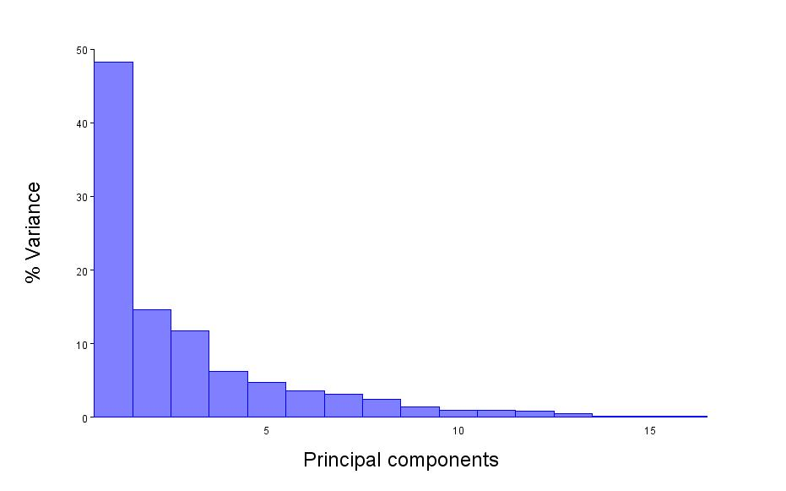
Suppl. Fig. 5. Proportion of the total variation explained by each principal component in the second analysis (MMCh-PV 293)

Principal Component Analysis: PCA: CovMatrix, newDataset, Procrustes coordinates
Eigenvalues % Variance Cumulative %
1. 0,01596228 48,213 48,213
2. 0,00483300 14,598 62,810
3. 0,00390102 11,783 74,593
4. 0,00206720 6,244 80,837
5. 0,00156148 4,716 85,553
6. 0,00120865 3,651 89,204
7. 0,00105041 3,173 92,376
8. 0,00082225 2,484 94,860
9. 0,00045771 1,382 96,242
10. 0,00033272 1,005 97,247
11. 0,00031188 0,942 98,189
12. 0,00027625 0,834 99,024
13. 0,00016615 0,502 99,526
14. 0,00006260 0,189 99,715
15. 0,00005210 0,157 99,872
16. 0,00004234 0,128 100,000
Total variance: 0,03310805

Variance of the eigenvalues: 0,0000147089345
Eigenvalue variance scaled by total variance: 0,01342
Eigenvalue variance scaled by total variance and number of variables: 0,22901
Note: throughout all calculations of eigenvalue variances, the dimensionality used was 16.
Please double-check because this dimensionality may not be appropriate for all situations.

Principal Component Coefficients
PC1 PC2 PC3 PC4 PC5 PC6 PC7 PC8 PC9 PC10 PC11 PC12 PC13 PC14 PC15 PC16
x1 -0,218011 0,389327 -0,034201 -0,143130 0,350155 -0,244474 -0,029916 0,147419 -0,036909 -0,229748 -0,097169 -0,202269 -0,177390 0,145289 -0,194161 0,141003
y1 0,085518 0,016182 -0,184992 -0,032858 -0,144287 0,112939 0,370895 -0,219671 -0,123059 -0,098859 -0,368347 0,196996 0,061377 0,269599 -0,172254 0,269493
x2 -0,146807 -0,027471 -0,310037 -0,017186 -0,223426 0,184637 0,148459 0,100665 -0,076105 -0,040437 -0,011072 -0,332418 0,390102 -0,219754 0,365959 -0,338999
y2 -0,300377 0,318709 0,206204 0,143779 0,410256 -0,074001 0,266963 -0,138678 -0,135426 0,219238 0,346275 0,130860 0,043483 -0,202934 0,149007 -0,119517
x3 -0,115240 -0,033896 -0,127798 0,152121 -0,236163 0,246139 0,044360 0,451090 0,241636 0,295211 0,295384 0,248276 -0,346711 -0,007328 -0,259873 0,035188
y3 -0,423377 -0,124345 0,084379 -0,136088 0,225949 0,315548 -0,390959 0,100176 0,391089 -0,016384 -0,338702 -0,027604 0,076219 0,187290 0,099942 -0,075764
x4 -0,098653 -0,121650 0,489604 -0,271445 -0,175366 0,073682 0,209737 -0,291510 0,055852 0,199468 -0,214036 0,330169 -0,044849 -0,136085 0,077528 -0,087072
y4 0,478063 -0,074453 -0,121486 -0,231826 0,122604 -0,140603 -0,361936 -0,224330 0,222554 0,124716 0,110527 0,003387 -0,195575 -0,252833 0,034472 -0,188525
x5 -0,024743 -0,379170 -0,036008 -0,014528 0,214801 0,112442 -0,173839 -0,252459 -0,126021 0,207217 0,328789 -0,139693 0,405181 0,073234 -0,250741 0,423114
y5 0,160956 0,056899 0,516856 0,071498 -0,315598 0,064237 0,093328 0,014344 0,148200 -0,147635 0,302014 -0,483347 -0,036939 0,333567 0,031494 0,015374
x6 0,001509 -0,017952 0,038850 0,160930 -0,112627 -0,130260 -0,344153 -0,035487 -0,159078 -0,428935 0,207116 0,457420 -0,008442 0,225055 0,440183 0,080961
y6 -0,165370 -0,139482 0,116341 -0,075761 -0,178179 0,135474 -0,198210 0,092086 -0,506296 -0,324717 -0,031818 -0,071472 -0,191592 -0,472671 -0,312358 -0,002912
x7 0,077394 0,221383 0,177655 0,398822 -0,201687 -0,382626 -0,203202 0,004464 0,188362 0,143535 -0,361915 -0,094906 0,225802 -0,280584 -0,142804 0,135085
y7 -0,319794 -0,260414 -0,301146 -0,152556 -0,229762 -0,593409 0,182755 -0,073561 0,235113 -0,080907 0,163887 0,030681 0,018595 0,060287 -0,100485 -0,083405
x8 0,088993 -0,221858 -0,042916 0,268357 0,166287 -0,056873 0,000572 -0,156338 -0,296861 0,147711 -0,170215 -0,136701 -0,266325 0,367466 -0,152001 -0,547090
y8 0,120767 -0,185528 -0,031580 0,009543 0,059098 -0,160315 0,044902 0,381300 -0,283058 0,386304 -0,198483 -0,109935 -0,168389 0,032228 0,461107 0,350375
x9 0,200784 -0,163660 -0,093907 0,098435 0,287293 0,170260 0,356958 -0,097558 0,320179 -0,377737 -0,034903 -0,134293 -0,274405 -0,277080 0,151167 0,196986
y9 0,349737 -0,040272 0,065571 0,148872 0,227895 0,036967 0,133123 0,404441 0,044660 -0,174097 -0,011723 0,307307 0,450985 0,013522 -0,213897 -0,225939
x10 0,234775 0,354947 -0,061243 -0,632377 -0,069265 0,027075 -0,008975 0,129716 -0,111055 0,083717 0,058020 0,004415 0,097036 0,109786 -0,035258 -0,039177
y10 0,013877 0,432705 -0,350147 0,255397 -0,177976 0,303162 -0,140861 -0,336108 0,006224 0,112340 0,026371 0,023127 -0,058164 0,031946 0,022973 0,060820

Results of the CVA for MMCh-PV 294
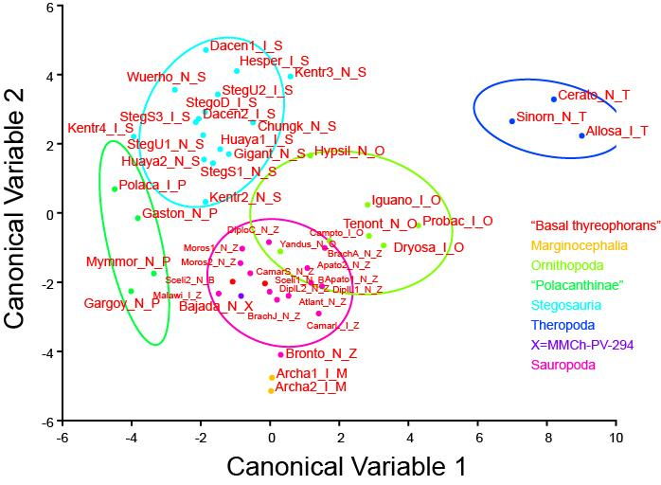

Suppl. Fig. 6. Canonical Variate Analysis (CVA) of MMCh-PV 294, the anterior sacral fragment. Confidence ellipses of Diplododoidea (turquoise), Macronaria (blue), Ornithopoda (yellow), Polacanthidae (light blue), Stegosauria (pink), other ornithischians (green) and Theropoda (orange) are shown.

Dataset: newDataset
Classification criterion: group
Groups Observations
1. B 2
2. M 2
3. O 7
4. P 4
5. S 16
6. T 3
7. X 1
8. Z 14

Variation among groups, scaled by the inverse of the within-group variation
Eigenvalues % Variance Cumulative %
1. 8,37973459 40,889 40,889
2. 6,23716353 30,434 71,322
3. 2,37957580 11,611 82,934
4. 1,61353051 7,873 90,807
5. 0,88164468 4,302 95,109
6. 0,69586779 3,395 98,504
7. 0,30657427 1,496 100,000

Mahalanobis distances among groups:
B M O P S T X
M 5,9800
O 5,3448 6,6398
P 4,9209 7,8047 7,5400
S 5,6270 8,6497 5,7248 5,6407
T 10,2902 12,1376 7,9662 12,7444 10,1342
X 6,6484 7,8287 7,1670 7,4184 7,8655 12,0687
Z 3,6313 6,0244 4,9215 6,1802 5,3062 9,5548 6,7485

P-values from permutation tests (10000 permutation rounds) for Mahalanobis distances among groups:
B M O P S T X
M 0,3324
O 0,0007 0,0030
P 0,0608 0,0697 0,0017
S 0,0015 <.0001 <.0001 <.0001
T 0,0670 <.0001 0,0061 0,0270 <.0001
X 0,3366 <.0001 0,0096 0,1654 0,0059 0,0861
Z 0,4820 0,0052 <.0001 0,0001 <.0001 0,0011 0,0016

Procrustes distances among groups:
B M O P S T X
M 0,1516
O 0,2372 0,1905
P 0,1779 0,2735 0,3287
S 0,1881 0,2466 0,3215 0,1487
T 0,3364 0,2948 0,1580 0,4328 0,4365
X 0,2212 0,2022 0,1756 0,2382 0,2264 0,2891
Z 0,0762 0,1399 0,2319 0,2103 0,1773 0,3307 0,2204

P-values from permutation tests (10000 permutation rounds) for Procrustes distances among groups:
B M O P S T X
M 0,3324
O 0,0047 0,0434
P 0,0608 0,0697 0,0025
S 0,0077 0,0013 <.0001 0,0011
T 0,0983 0,0997 0,0767 0,0279 0,0009
X 0,3366 0,3349 0,3935 0,2013 0,1002 0,2570
Z 0,9158 0,3820 0,0008 0,0077 0,0001 0,0043 0,1934

Canonical coefficients:
CV1 CV2 CV3 CV4 CV5 CV6 CV7
x1 -5,6897 -15,2261 -3,6183 13,0990 -11,2277 -3,0213 -5,0116
y1 0,4004 8,7125 -0,4082 -16,7101 -21,4287 4,3949 -5,3244
x2 -20,5976 -3,3532 -14,2981 -8,9427 -16,1143 -5,7634 -7,4390
y2 -4,3263 -9,0881 12,8393 17,6873 22,4630 -22,6212 -2,0741
x3 -2,8475 -1,0321 14,0023 -7,1546 1,7001 -9,1854 2,0218
y3 -9,5644 -9,6338 4,7206 -13,6543 -2,6509 11,0320 -2,2038
x4 10,6845 -10,1557 -20,3233 -3,8487 14,3727 2,1847 5,4799
y4 -49,0638 -13,2610 34,6040 36,1299 -26,3704 19,7701 16,6144
x5 -1,6152 29,4349 19,5651 -1,7079 24,5602 26,1853 47,1670
y5 64,0041 18,0665 -62,4496 -32,6755 26,0390 -2,7311 -25,4499
x6 9,7255 -20,2608 -16,7622 16,1927 9,5410 23,7411 -16,2151
y6 12,8080 20,9602 -27,5359 2,5123 12,7891 -12,9318 0,9434
x7 -10,7801 24,4539 17,6920 -1,6322 -0,2567 7,1098 2,7435
y7 35,9050 -34,6691 -35,1673 -27,1452 37,2893 -7,4907 -10,6307
x8 34,8143 -23,2607 -6,6277 -8,2833 -32,2640 -6,8309 -46,5697
y8 -46,8272 70,7678 31,9907 25,7872 -45,2637 9,9376 21,3421
x9 23,8654 27,6038 -8,6268 -3,0709 -22,4309 10,0770 10,1290
y9 20,2723 -25,9001 -4,7742 10,1805 -5,9436 4,7542 -11,0349
x10 15,6399 7,1050 -5,3234 7,6360 0,3904 9,8119 -25,7625
y10 42,4905 41,3104 -13,0950 25,0399 8,5953 0,0269 -3,1951
x11 -8,8050 7,6650 38,4284 -23,1771 -33,1700 2,4504 29,7258
y11 -44,2548 -50,9161 33,4821 -18,7511 -12,8015 17,5735 10,9969
x12 14,9192 11,1868 -15,0757 -3,3088 5,5526 -16,7500 -11,6234
y12 5,1704 -20,0950 15,5986 -17,3041 -24,5594 -27,0917 20,3329
x13 -59,3138 -34,1608 0,9678 24,1984 59,3465 -40,0093 15,3544
y13 -27,0143 3,7459 10,1949 8,9033 31,8424 5,3776 -10,3166

Results of the CVA for MMCh-PV 293
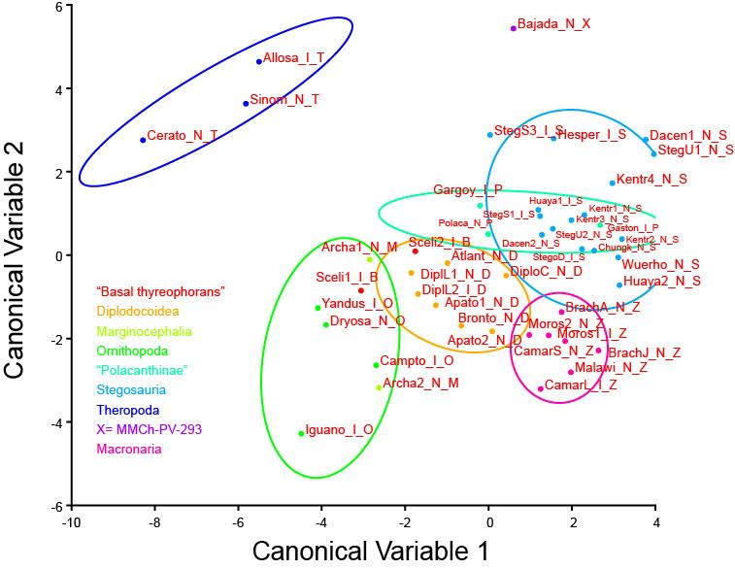

Suppl. Fig. 7. Canonical Variate Analysis (CVA) of MMCh-PV 293, the anterior sacral fragment.

Dataset: newDataset
Classification criterion: group
Groups Observations
1. B 2
2. D 7
3. M 2
4. O 4
5. P 3
6. S 16
7. T 3
8. X 1
9. Z 7

Variation among groups, scaled by the inverse of the within-group variation
Eigenvalues % Variance Cumulative %
1. 8,91957016 49,864 49,864
2. 4,50133115 25,164 75,028
3. 1,70425924 9,527 84,556
4. 1,17022267 6,542 91,098
5. 0,77323775 4,323 95,420
6. 0,53501481 2,991 98,411
7. 0,17929671 1,002 99,414
8. 0,10491024 0,586 100,000

Mahalanobis distances among groups:
B D M O P S T X
D 5,1039
M 4,5907 4,4718
O 4,5158 4,2661 3,8128
P 5,2544 5,2541 5,1053 6,3995
S 6,0628 4,1297 6,3676 7,2158 3,5857
T 7,4054 7,7379 7,1350 7,5088 8,8188 9,3608
X 8,8464 8,4199 9,3986 10,1665 7,0060 6,9982 9,2788
Z 6,1586 4,0466 5,1058 6,3415 4,6397 4,0052 10,2125 8,9770

P-values from permutation tests (10000 permutation rounds) for Mahalanobis distances among groups:
B D M O P S T X
D 0,0069
M <.0001 0,0191
O 0,0349 0,0045 0,2406
P 0,0937 0,0058 0,0334 0,0053
S 0,0021 <.0001 0,0055 0,0001 0,0025
T <.0001 <.0001 <.0001 0,0015 0,0954 0,0009
X 0,3266 0,1206 0,3340 0,1311 0,2490 0,0244 <.0001
Z 0,0103 0,0001 0,0032 0,0006 0,0038 <.0001 0,0041 0,0833

Procrustes distances among groups:
B D M O P S T X
D 0,1610
M 0,1272 0,1422
O 0,1396 0,1247 0,1181
P 0,1673 0,2267 0,1687 0,2414
S 0,1780 0,1727 0,2026 0,2484 0,1422
T 0,3159 0,2779 0,2690 0,2545 0,4158 0,3962
X 0,1824 0,2092 0,1648 0,2340 0,1880 0,1910 0,3105
Z 0,1696 0,1698 0,1752 0,2197 0,1181 0,1075 0,4105 0,2048

P-values from permutation tests (10000 permutation rounds) for Procrustes distances among groups:
B D M O P S T X
D 0,0475
M 0,3382 0,2284
O 0,1210 0,0827 0,2421
P 0,0937 0,0075 0,1997 0,0268
S 0,0044 <.0001 0,0074 <.0001 0,0015
T 0,0986 0,0072 0,0691 0,0180 0,0823 0,0012
X 0,3266 0,3808 0,3340 0,0160 0,2490 0,0496 <.0001
Z 0,0736 0,0044 0,0883 0,0014 0,2828 0,0030 0,0081 0,4911

Canonical coefficients:
CV1 CV2 CV3 CV4 CV5 CV6 CV7 CV8
x1 -15,8489 -34,0201 -8,9912 -8,0202 -22,7850 2,5627 -0,8220 -0,8744
y1 -22,5707 -23,8842 -13,6096 -13,3701 -36,6803 3,9744 -0,1839 -21,0791
x2 16,6126 16,2715 14,6078 21,1314 59,1766 -3,9176 22,7454 8,5877
y2 8,7136 15,9949 7,2254 10,1308 17,3141 -11,6371 -18,3224 6,4881
x3 -2,4356 19,7335 -12,1107 -7,4789 -27,4893 11,0905 -25,8245 17,6360
y3 -25,6483 3,6662 -4,2979 5,8456 1,1549 3,2203 31,4917 -6,8115
x4 -5,9475 14,4636 -1,2111 -10,2828 -6,3965 -0,8404 1,4058 4,5181
y4 28,5220 5,2643 19,1279 -7,0935 9,1869 4,9283 -0,1070 23,1531
x5 5,6393 38,6080 6,1291 -15,0173 -8,4556 -1,8561 -29,7672 -10,2702
y5 0,7669 0,3596 -18,2577 9,3041 21,6539 19,9217 8,0109 -18,5366
x6 -11,8822 -21,9647 5,3653 20,9418 22,1845 -39,6282 11,5634 -43,2496
y6 30,5860 3,5779 13,1186 -24,0547 -25,7083 -5,5528 -9,7719 39,7314
x7 -9,5586 5,5209 -2,1989 -15,2504 -7,0698 10,0379 -8,0598 11,2956
y7 5,6884 -13,7850 5,3225 -19,4882 8,3707 10,7100 -4,6203 -7,3869
x8 23,9524 -23,8267 -7,8310 32,8859 -2,5461 31,3499 39,4543 7,1280
y8 -53,1910 2,3161 3,5632 47,5073 7,7833 -25,8974 -16,5463 -15,8154
x9 -6,2447 -16,3307 15,9112 -15,0388 -15,9505 -2,1244 -14,3010 1,8201
y9 30,6642 11,7101 -15,4461 -15,3888 -2,2496 -8,0927 12,1269 -1,3630
x10 5,7133 1,5447 -9,6706 -3,8707 9,3316 -6,6742 3,6056 3,4086
y10 -3,5310 -5,2199 3,2537 6,6075 -0,8256 8,4252 -2,0777 1,6197

Sample for PCA and CVA analyses
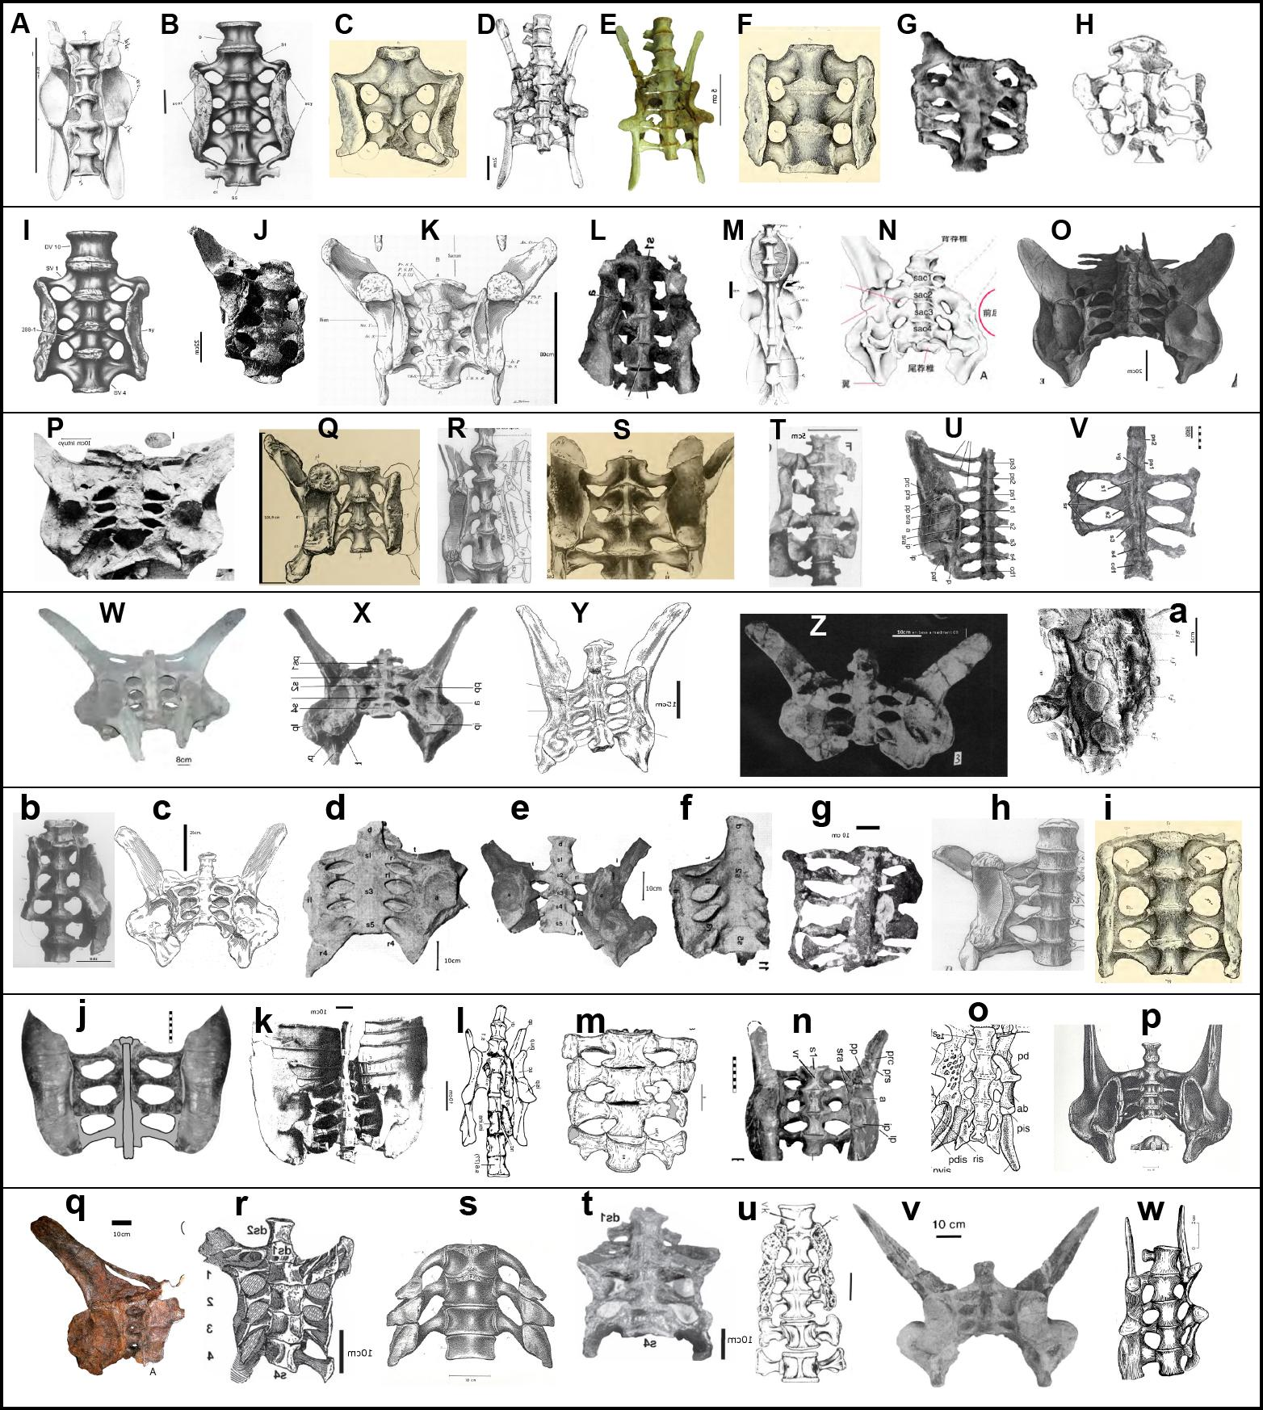
Suppl. Fig. 8. Pelvis of: A) Allosaurus; B, C) Apatosaurus; D, E) Archaeoceratops; F) Atlantosaurus; G) Brachiosaurus adult; H) Brachiosaurus juvenil; I) Brontosaurus; J, K) Camarasaurus; L) Camptosaurus; M) Ceratosaurus; N) Chungkingosaurus; O, P) Dacentrurus; Q, R, S) Diplodocus; T) Dryosaurus; U) Gargoyleosaurus; V) Gastonia; W) Gigantspinosaurus; X) Hesperosaurus; Y, Z) Huayangosaurus; a) Hypsilophodon; b) Iguanodon; c, d, e, f) Kentrosaurus; g) Malawisaurus; h,i) Morosaurus; j) Mymoorapelta; k) Polacanthus; l) Probactrosaurus; m, n) Scelidosaurus; o) Sinornithosaurus; p, q, r, s, t) Stegosaurus; u) Tenontosaurus; v) Wuerhosaurus; w) Yandusaurus. Figures are not to scale.

List of sampled materials for PCA and CVA: Allosaurus (USNM 4734; Gilmore, 1920); Apatosaurus (=Atlantosaurus=Brontosaurus; YPM 1840, 1860 and 1981; Marsh, 1986; Ostrom and McIntosh, 1966; Tschopp et al., 2015); Archaeoceratops (IVPP V 11114; You and Dodson, 2004); Brachiosaurus (HMN T and FMNH P 25107; Taylor, 2009); Camarasaurus (BYU 4097, AMNH 5761; Osborn and Mook, 1921; McIntosh et al., 1996); Camptosaurus (CM 11337; Carpenter and Wilson, 2008); Ceratosaurus (USNM 4735; Gilmore, 1920); Chungkingosaurus (CQMNH-CV00206; Hao et al., 2018); Dacentrurus (NHMUK 46013; Galton, 1985; Maidment et al., 2008); Diplodocus (AMNH 516, CM 94, YPM 1920; Hatcher, 1901; Osborn, 1904); Dryosaurus (HMN dy II; Galton, 1981); Gargoyleosaurus (DMNH 58831; Carpenter et al., 2013); Gastonia (DMNH 53883; Kinneer et al. 2016); Gigantspinosaurus (ZDM 0156; Hao et al., 2018); Hesperosaurus (HMNH 001; Carpenter et al., 2013); Huayangosaurus (CV 00721, ZDM T7001; Zhou, 1983; Maidment et al., 2006); Hypsilophodon (NHMUK Fox Collection R195; Hulke, 1882); Iguanodon (unnumb. Owen, 1854); Kentrosaurus (MfN St 218, 439 and 500; Hennig, 1925; Galton, 1982); Malawisaurus (Mal-277-1; Gomani, 2005); Morosaurus (AMNH 690, YPM 1900; Marsh, 1986; Osborn, 1904; Ostrom and McIntosh, 1966;); Mymoorapelta (MWC 1815; Carpenter et al., 2013); Polacanthus (NHMUK R175; Pereda-Suberbiola, 1993); Probactrosaurus (PIN 2232/10; Norman, 2002); Scelidosaurus (NHMUK R1111; Carpenter et al., 2013; Norman, 2020); Sinornithosaurus (IVPP V12811; Xu et al., 1999); Stegosaurus (HMNS 14, NHMUK PV R36730, USNM V 4934, YPM 1858; Ostrom and McIntosh, 1966; Maidment et al., 2015; Galton and Carpenter, 2016); Tenontosaurus (AMNH 3040; Forster, 1990); Wuerhosaurus (IVPP V4006; Dong, 1990); Yandusaurus (T6001; He and Cai, 1984).

References
Carpenter, K. and Wilson, Y. (2008). A new species of Camptosaurus (Ornithopoda: Dinosauria) from the Morrison Formation (Upper Jurassic) of Dinosaur National Monument, Utah, and a biomechanical analysis of its forelimb. Annals of Carnegie Museum, 76(4), 227–263.
Carpenter, K., DiCroce, T., Kinneer, B. and Simon, R. (2013). Pelvis of Gargoyleosaurus (Dinosauria: Ankylosauria) and the origin and evolution of the ankylosaur pelvis. PLoS ONE, 8(11), e79887.
Dong, Z. (1990). Stegosaurs of Asia. In Dinosaur systematics symposium (pp. 255–268).
Forster, C. A. (1990). The postcranial skeleton of the ornithopod dinosaur Tenontosaurus tilletti. Journal of Vertebrate Paleontology, 10(3), 273–294.
Galton, P. M. (1981). Dryosaurus, a hypsilophodontid dinosaur from the Upper Jurassic of North America and Africa postcranial skeleton. Paläontologische Zeitschrift, 55(3), 271–312.
Galton, P. M. (1982). The postcranial anatomy of stegosaurian dinosaur Kentrosaurus from the Upper Jurassic of Tanzania, East Africa. Geologica et Paleontologica, 15, 139–160.
Galton, P. M. (1985). British plated dinosaurs (Ornithischia, Stegosauridae). Journal of Vertebrate Paleontology, 5(3), 211–254.
Galton, P. M. and Carpenter, K. (2016). The plated dinosaur Stegosaurus longispinus Gilmore, 1914 (Dinosauria: Ornithischia; Upper Jurassic, western USA), type species of Alcovasaurus n. gen. Neues Jahrbuch für Geologie und Paläontologie, Abhandlungen, 279(2), 185–208.
Gilmore, C. W. (1920). Osteology of the carnivorous Dinosauria in the United State National museum: with special reference to the genera Antrodemus (Allosaurus) and Ceratosaurus (No. 110). US Government printing office.
Gomani, E. M. (2005). Sauropod dinosaurs from the early Cretaceous of Malawi, Africa. Palaeontologia Electronica, 8(1), 1.
Hao, B., Peng, G., Qin, G., Ye, Y. and Jiang, S. (2018). Evolution of Pelvic Girdles of Stegosaurus in the Sichuan Basin. Acta Geologica Sichuan, 38(1), 62–64.
Hatcher, J. B. (1901). Diplodocus (Marsh): its osteology, taxonomy, and probable habits, with a restoration of the skeleton. Carnegie Museum, 1(1), 63 pp.
He, X. L. and Cai, K. (1984). The Middle Jurassic Dinosaurian Fauna from Dashanpu, Zigong, Sichuan. Vol 1, The Ornithopod Dinosaurs. Chengdu: Sichuan Scientific and Technological Publishing House, 71, 1–66.
Hennig, E. (1925). Kentrurosaurus aethiopicus; die Stegosaurierfunde vom Tendaguru, Deutsch-Ostafrika. Palaeontographica-Supplementbände, 101–254.
Hulke, J. W. (1882). XXIV. An attempt at a complete osteology of hypsilophodon foxii; a British Wealden dinosaur. Philosophical Transactions of the Royal Society of London, (173), 1035-1062.
Kinneer, B., Carpenter, K. and Shaw, A. (2016). Redescription of Gastonia burgei (Dinosauria: Ankylosauria, Polacanthidae), and description of a new species. Neues Jahrbuch für Geologie und Paläontologie Abhandlungen, 282, 37–80.
Maidment, S. C. R., Norman, D., Barrett, P. and Upchurch, P. (2008). Systematics and phylogeny of Stegosauria (Dinosauria: Ornithischia). Journal of Systematic Palaeontology, 6(4), 367e407.
Maidment, S. C., Wei, G., & Norman, D. B. (2006). Re-description of the postcranial skeleton of the Middle Jurassic stegosaur Huayangosaurus taibaii. Journal of Vertebrate Paleontology, 26(4), 944–956.
Maidment, S. C. R., Brassey, C. and Barrett, P. M. (2015). The postcranial skeleton of an exceptionally complete individual of the plated dinosaur Stegosaurus stenops (Dinosauria: Thyreophora) from the Upper Jurassic Morrison Formation of Wyoming, USA. PloS ONE, 10(10), e0138352.
Marsh, O. C. (1896). The dinosaurs of North America. US Government Printing Office, 16.
McIntosh, J. S., Miller, W. E., Stadtman, K. L. and Gillette, D. D. (1996). The osteology of Camarasaurus lewisi (Jensen, 1988). Brigham Young University Geology Studies, 41, 73–95.
Norman, D. B. (2002). On Asian ornithopods (Dinosauria: Ornithischia). 4. Probactrosaurus. Zoological Journal of the Linnean Society, 136(1), 113–144.
Norman, D. B. (2020). Scelidosaurus harrisonii from the Early Jurassic of Dorset, England: postcranial skeleton. Zoological Journal of the Linnean Society, 189(1), 47–157.
Osborn, H. F. (1904). Manus, sacrum, and caudals of Sauropoda. Bulletin of the American Museum of Natural History, 20(14).
Osborn, H. F. and Mook, C. C. (1921). Camarasaurus, Amphicoelias, and other sauropods of Cope. Bulletin of the Geological Society of America, 30(1), 379–388.
Owen, R. (1854) Monograph on the Fossil Reptilia of the Wealden and Purbeck Formations. Part II. Pages 1–54; Plates I—XIX and XVIA. Dinosauria (Iguanodon). [Wealden.]. Monographs of the Palaeontographical Society, 8(7), 1–54
Pereda-Suberbiola, J. (1994). Polacanthus (Ornithischia, Ankylosauria), a transatlantic armoured dinosaur from the Early Cretaceous of Europe and North America. Palaeontographica Abteilung A, 232(4-6), 133–159.
Taylor, M. P. (2009). A re-evaluation of Brachiosaurus altithorax Riggs 1903 (Dinosauria, Sauropoda) and its generic separation from Giraffatitan brancai (Janensch 1914). Journal of vertebrate Paleontology, 29(3), 787–806.
Tschopp, E., Mateus, O. and Benson, R. B. (2015). A specimen-level phylogenetic analysis and taxonomic revision of Diplodocidae (Dinosauria, Sauropoda). PeerJ, 3, e857.
Xu, X., Wang, X. L. and Wu, X. C. (1999). A dromaeosaurid dinosaur with a filamentous integument from the Yixian Formation of China. Nature, 401(6750), 262–266.
You, H. and Dodson, P. (2003). Redescription of neoceratopsian dinosaur Archaeoceratops and early evolution of Neoceratopsia. Acta Palaeontologica Polonica, 48(2).
Zhou, S.-W. 1983. A nearly complete skeleton of a stegosaur from the Middle Jurassic of Dashanpu, Zigong, Sichuan. Journal of Chengdu College of Geology, 1, 15–26. [Chinese, 15–25; English, 26]

