Supplementary Information – Marques et al., 2026. Automated multi-view silhouette generation and morphometric clustering of isolated theropod teeth using machine learning.

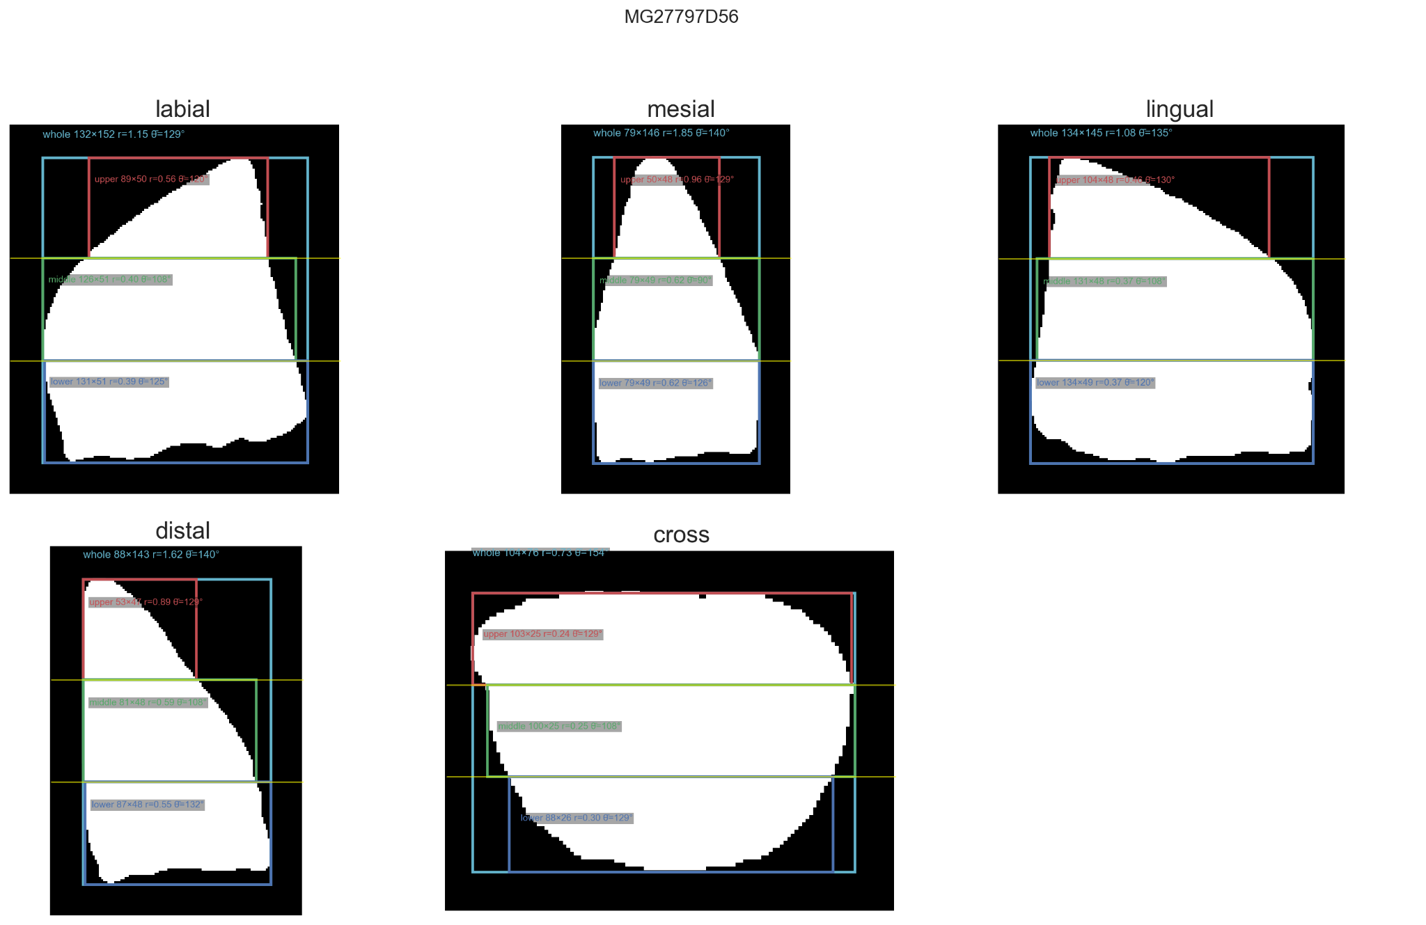
Figure S1. Representative tooth for cluster 0.
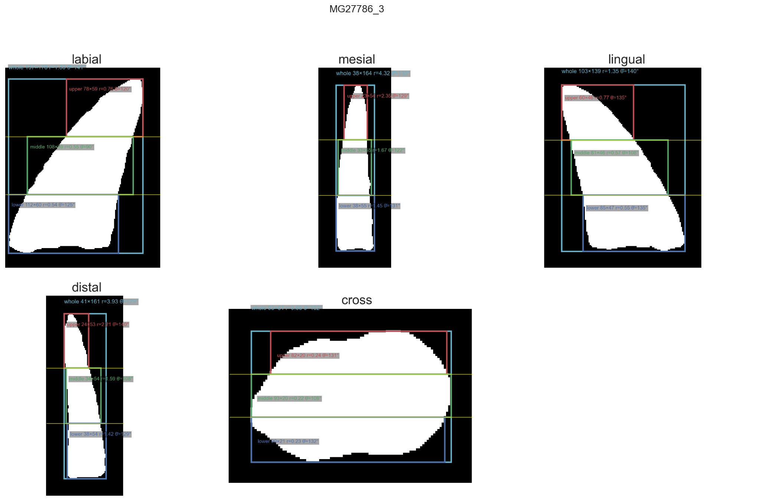
Figure S2. Representative tooth for cluster 1.
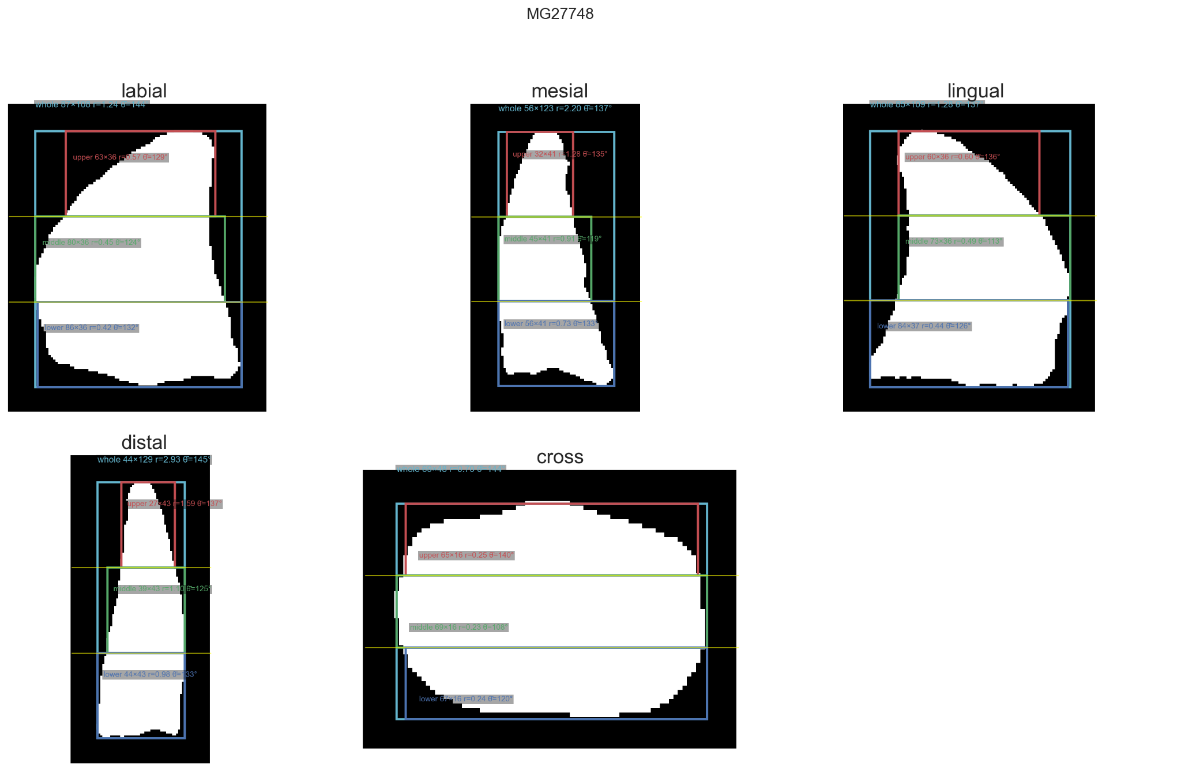
Figure S3. Representative tooth for cluster 2.
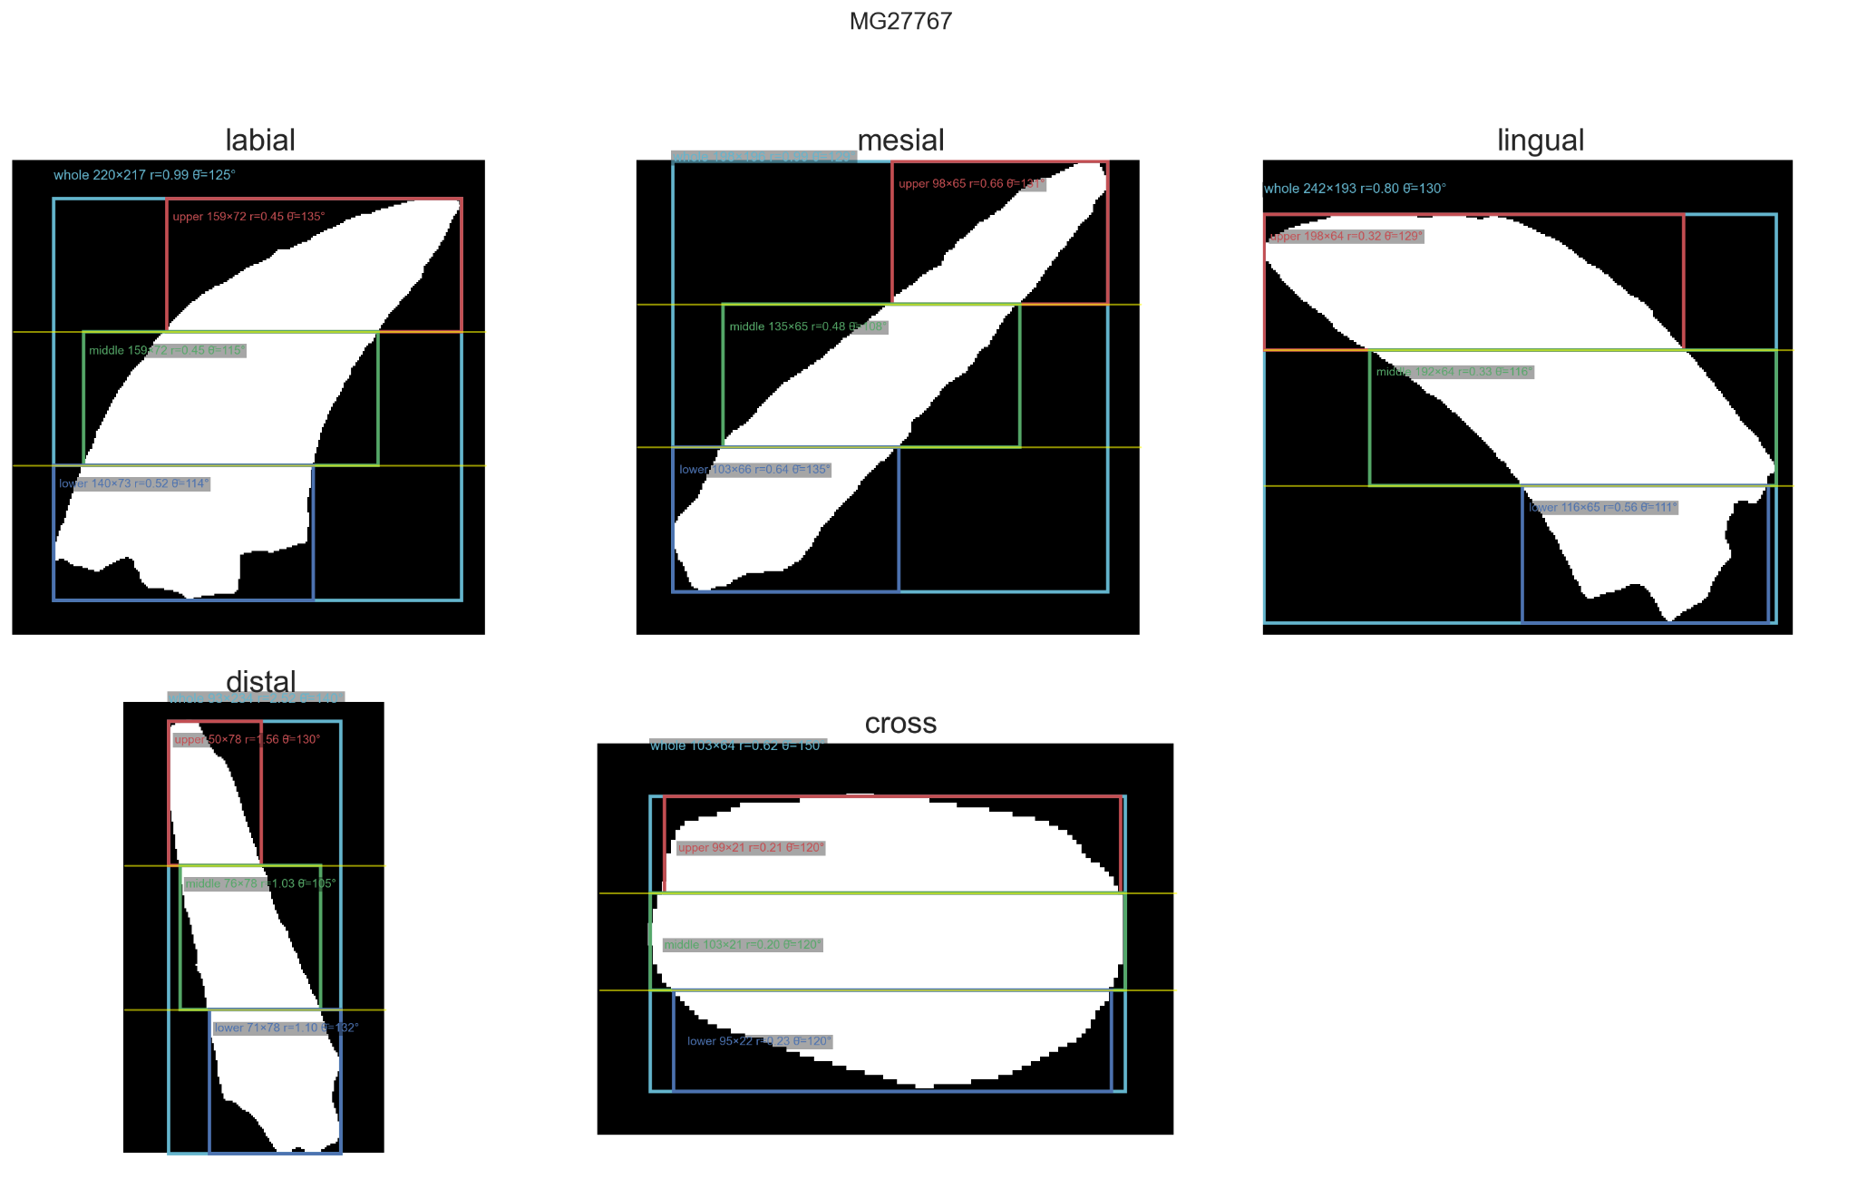
Figure S4. Representative tooth for cluster 3.
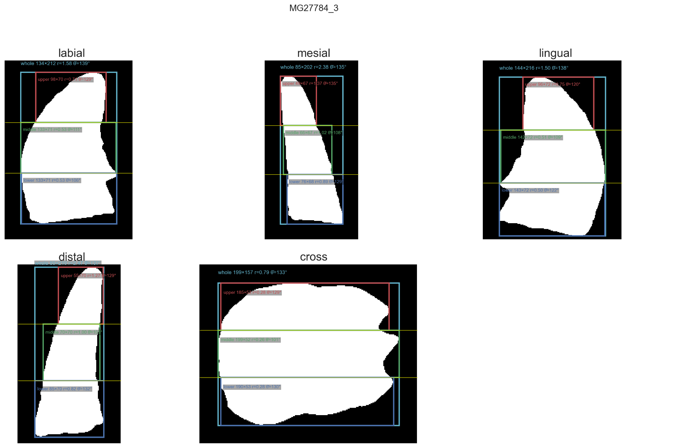
Figure S5. Representative tooth for cluster 4.
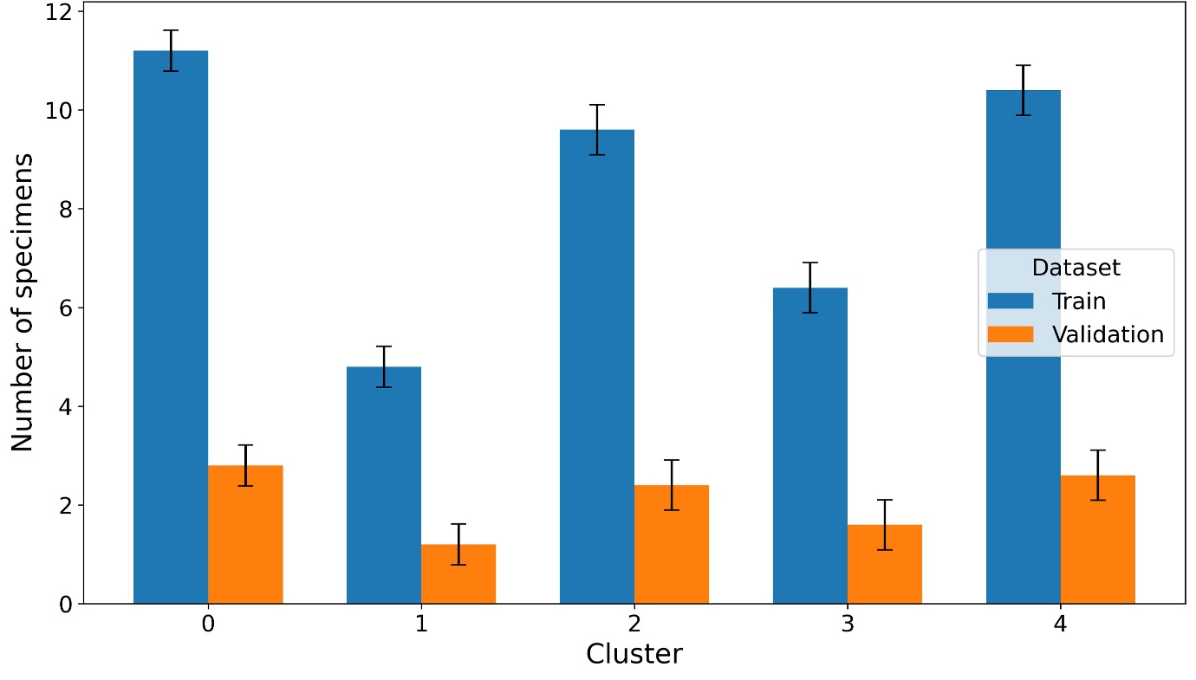
Figure S6. Random forest mean number of specimens per cluster in the training and validation partitions across repeated stratified cross-validation folds. Blue bars show training support and orange bars show validation support. Bars represent mean support across folds, and black error bars indicate ±1 standard deviation. The plot illustrates the unequal class sizes among the HDBSCAN-derived clusters, with Cluster 1 having the smallest number of specimens.
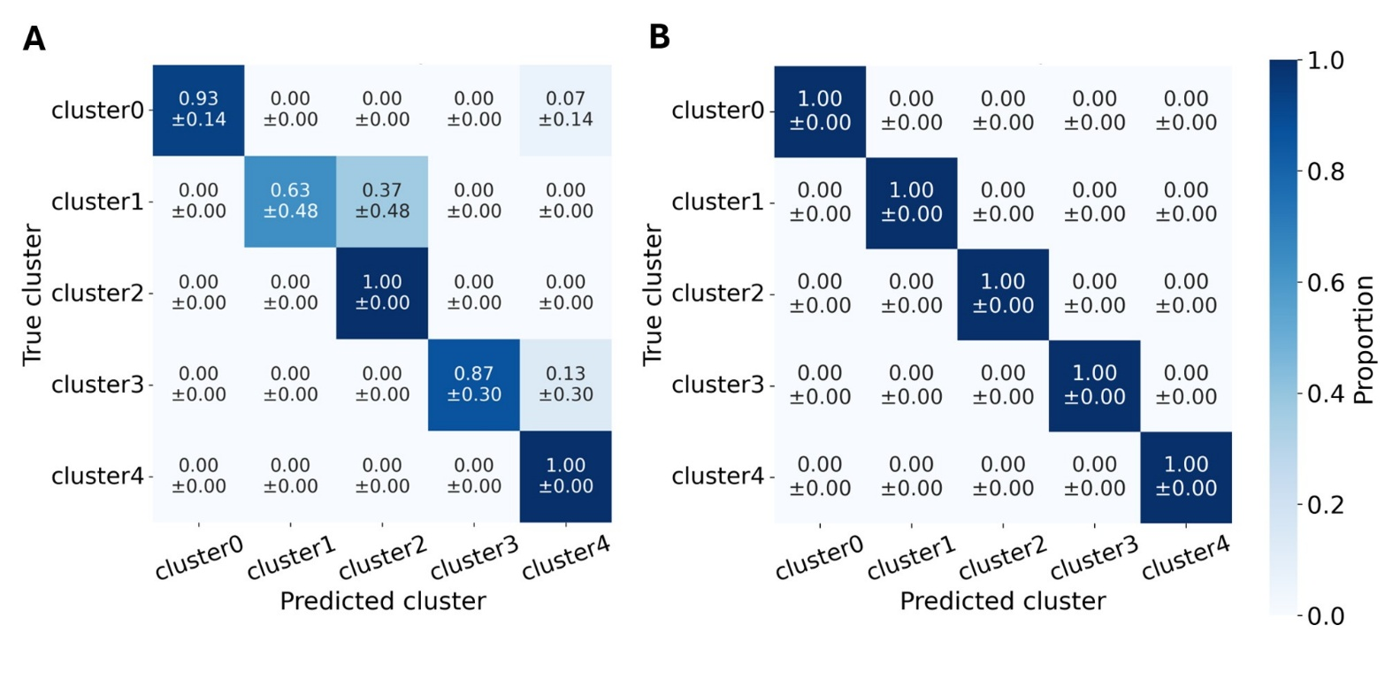
Figure S7. Normalized confusion matrix for mean and standard deviations for the predicted clusters across the cross-validation folds. Predictions were obtained from the random forest model.
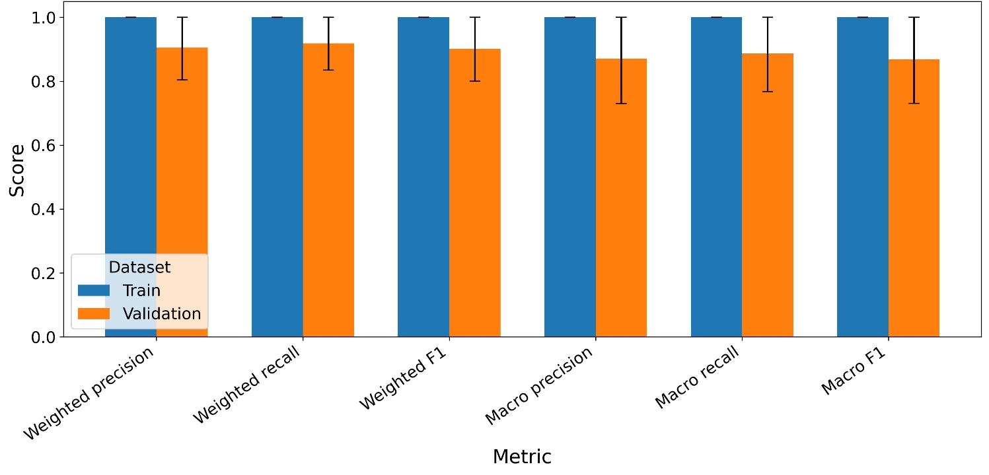
Figure S8. Random forest weighted and macro precision, recall, and F1-score for the random forest classifier across repeated stratified cross-validation folds. Blue bars show training performance and orange bars show validation performance. Bars represent mean values across folds, and black error bars indicate ±1 standard deviation. Training scores were consistently close to 1.00, whereas validation scores were slightly lower and more variable, reflecting fold-to-fold variation in the small held-out validation subsets
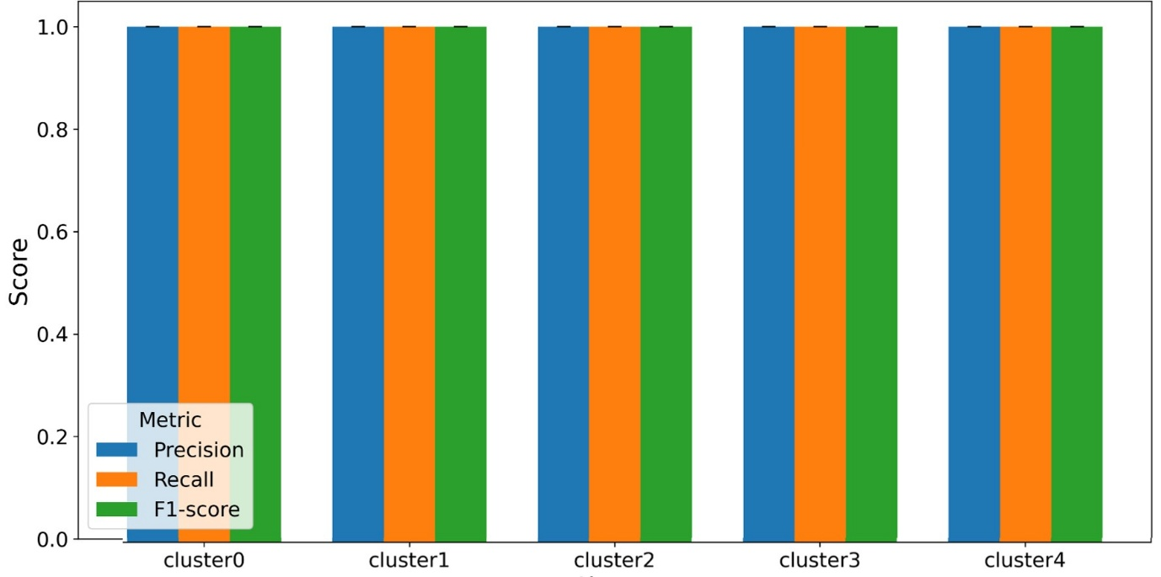
Figure S9. Random forest per-class training precision, recall, and F1-score for the random forest classifier across repeated stratified cross-validation folds. Bars represent mean values across folds, and black error bars indicate ±1 standard deviation. Training performance was essentially perfect for all five HDBSCAN-derived clusters, indicating that the random forest fully separated the cluster-derived classes in the training partitions.
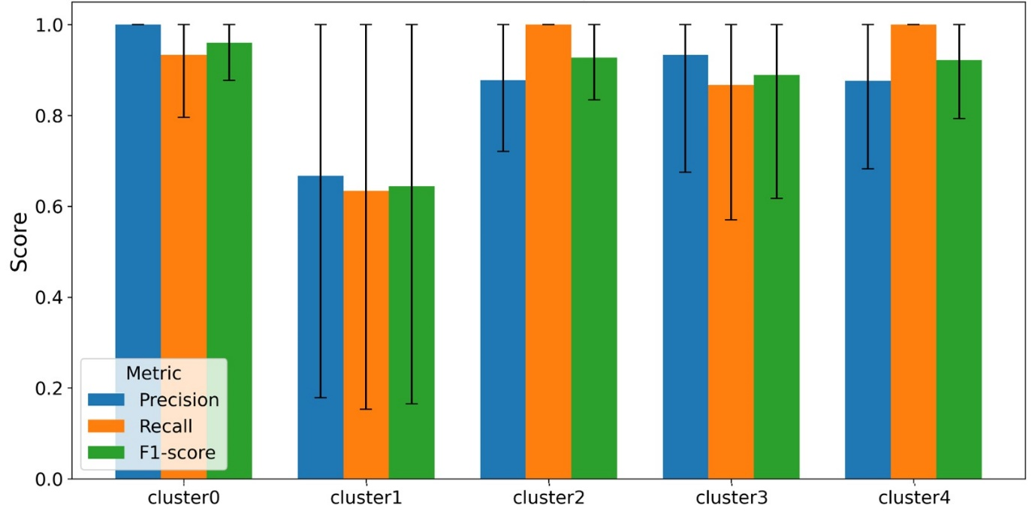
Figure S10. Random forest per-class validation precision, recall, and F1-score for the random forest classifier across repeated stratified cross-validation folds. Bars represent mean values across folds, and black error bars indicate ±1 standard deviation. Validation performance was highest for Clusters 0, 2, 3, and 4, whereas Cluster 1 showed lower and more variable precision, recall, and F1-score, consistent with its smaller sample size and greater overlap with neighbouring morphometric groups.
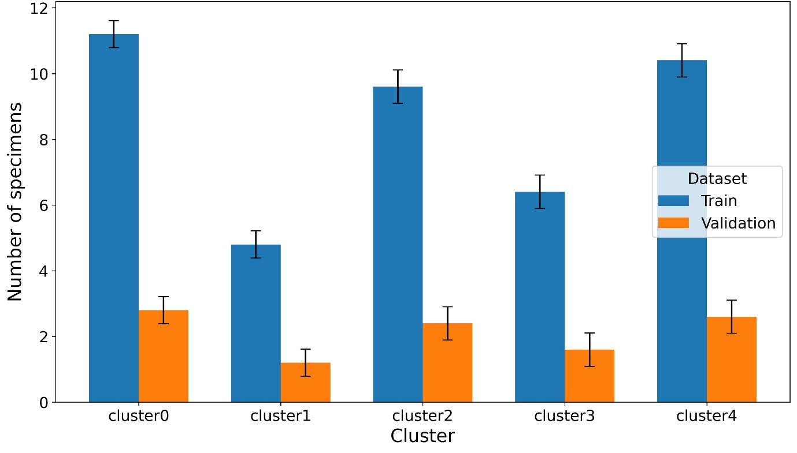
Figure S11. EfficientNet mean number of specimens per cluster in the training and validation partitions across repeated stratified cross-validation folds. Blue bars show training support and orange bars show validation support. Bars represent mean support across folds, and black error bars indicate ±1 standard deviation. The plot illustrates the unequal class sizes among the HDBSCAN-derived clusters, with Cluster 1 having the smallest number of specimens.
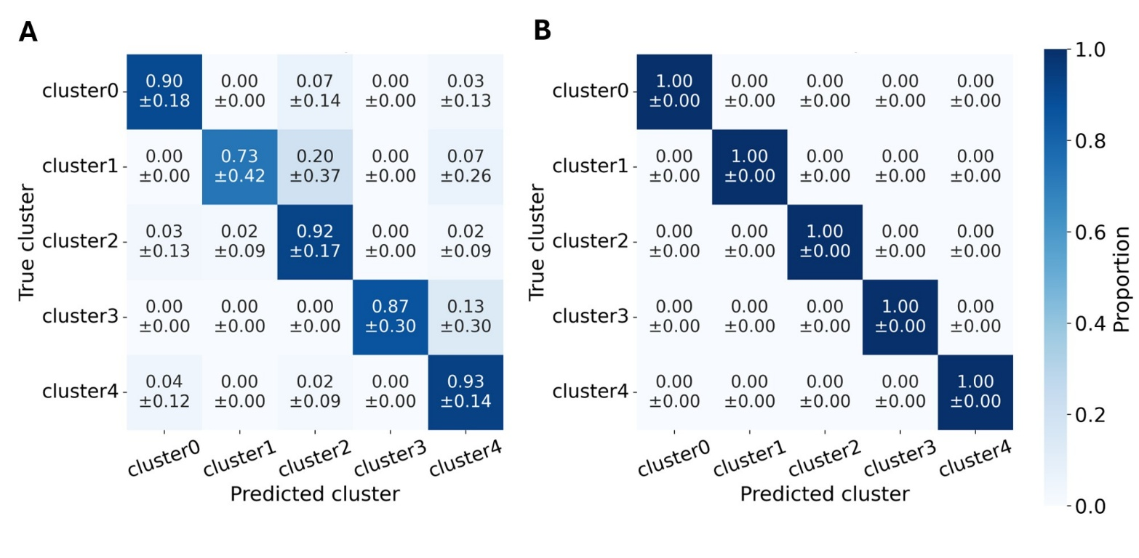
Figure S12. Normalized confusion matrix for the predicted clusters. Predictions were obtained from the EfficientNet model.

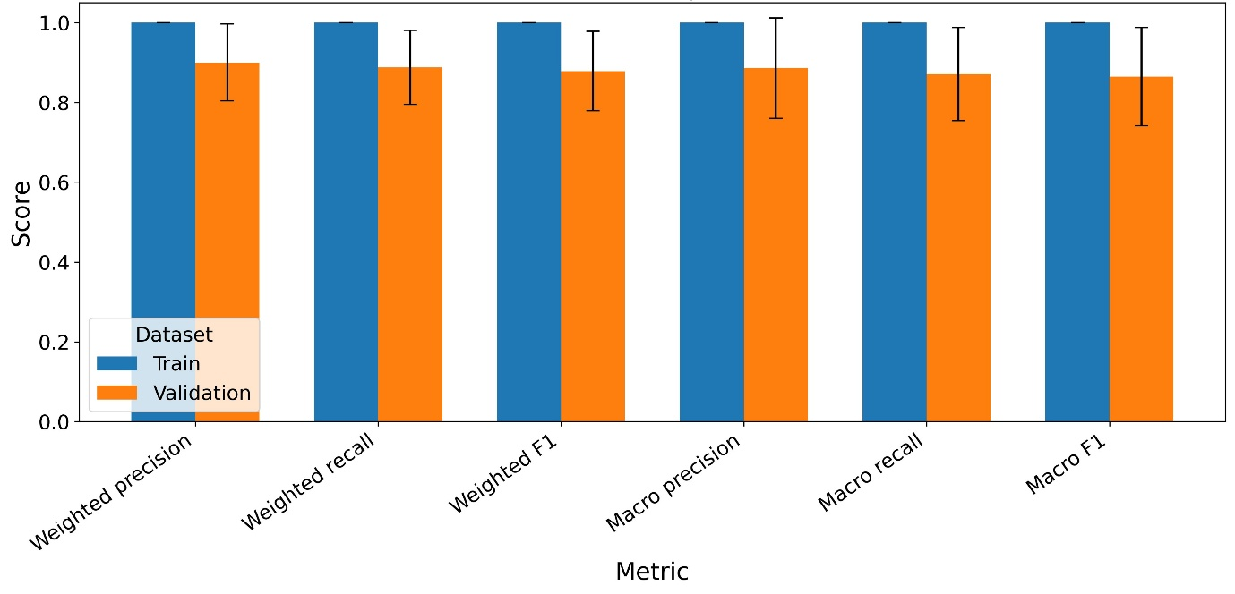
Figure S13. EfficientNet weighted and macro precision, recall, and F1-score for the EfficientNet classifier across repeated stratified cross-validation folds. Blue bars show training performance and orange bars show validation performance. Bars represent mean values across folds, and black error bars indicate ±1 standard deviation. Training scores were consistently close to 1.00, whereas validation scores were slightly lower and more variable, reflecting fold-to-fold variation in the small held-out validation subsets.

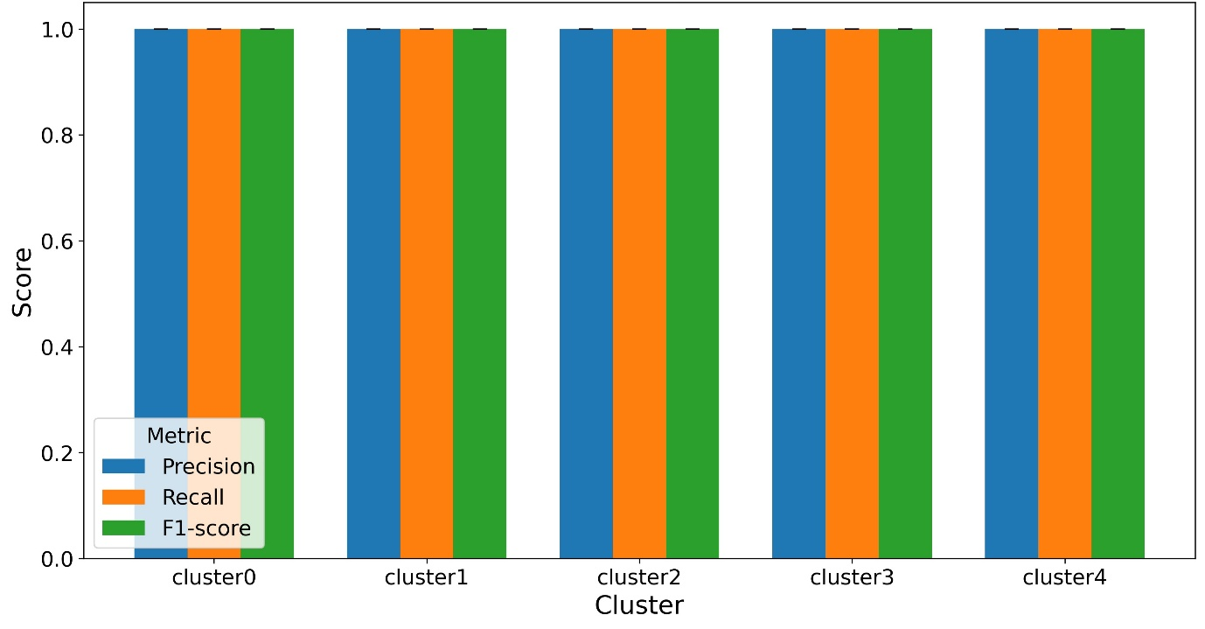
Figure S14. EfficientNet per-class training precision, recall, and F1-score for the EfficientNet classifier across repeated stratified cross-validation folds. Bars represent mean values across folds, and black error bars indicate ±1 standard deviation. Training performance was essentially perfect for all five HDBSCAN-derived clusters, indicating that the EfficientNet fully separated the cluster-derived classes in the training partitions.

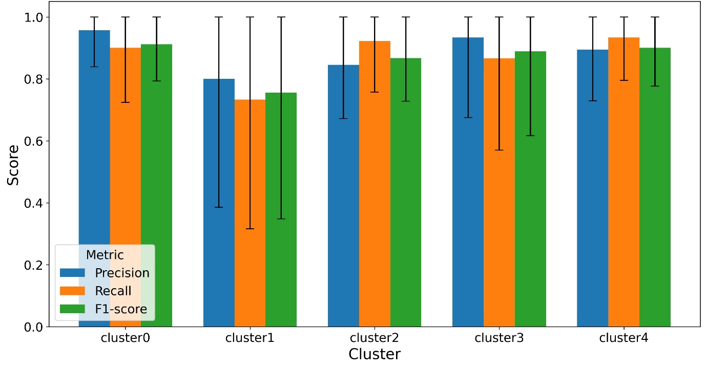
Figure S15. EfficientNet per-class validation precision, recall, and F1-score for the EfficientNet classifier across repeated stratified cross-validation folds. Bars represent mean values across folds, and black error bars indicate ±1 standard deviation. Validation performance was highest for Clusters 0, 2, 3, and 4, whereas Cluster 1 showed lower and more variable precision, recall, and F1-score, consistent with its smaller sample size and greater overlap with neighbouring morphometric groups.
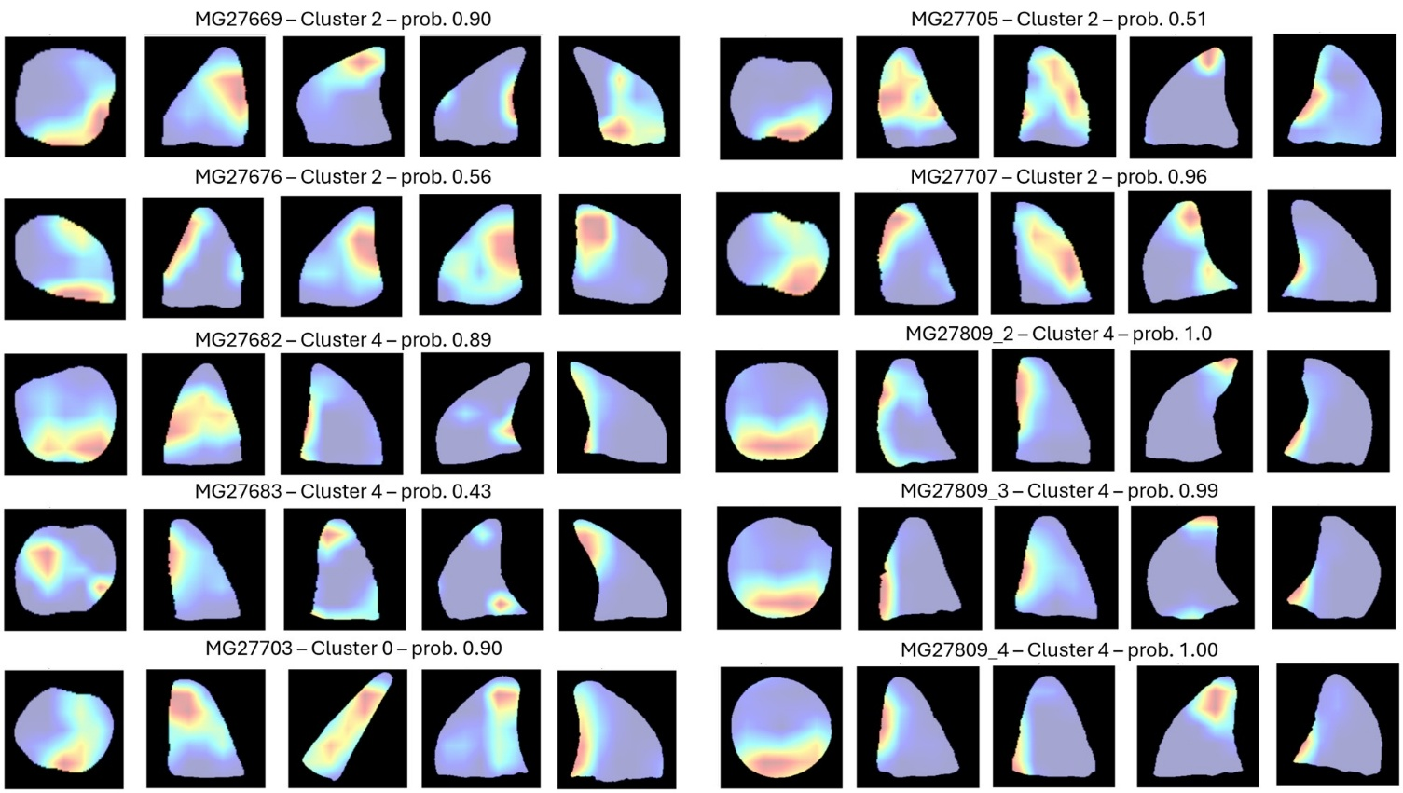
Figure S16. Grad-CAM summaries for unseen, test teeth. The five view-specific overlays show activation concentrated mainly on basal and lateral crown regions and on the lower perimeter of the cross-sectional silhouette.

